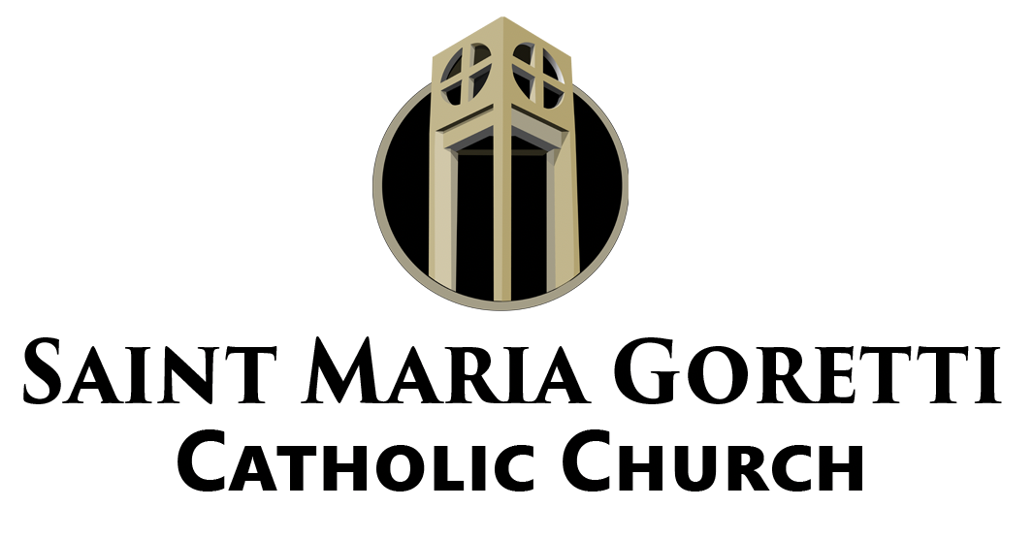

The Goretti Notes

Mass Intentions for the Week
Saturday, October 2nd
4:00 PM: Narvella Chambers

Sunday, October 3rd
8:30 AM: Walter Banks, III and Matt LeBlanc, Jr.
10:30 AM: Alvin J. Petit, Kevin Joseph Hebert, and Gloria Chase Wright Augustine
12:00 Noon: Parishioners of St. Maria Goretti

Monday, October 4th: Charles Winchell, Jr.
Tuesday, October 5th: Sr. Lou Petry, OP
Wednesday, October 6th: Audry Loredo
Thursday, October 7th: Lydia Kingvalsky
Friday, October 8th: Moses Faciane and Louis Isidore
Saturday, October 9th: In Thanksgiving and Moses Faciane

October: The Month of the Holy Rosary
Many people, in recent years, have taken to celebrating their birthdays not for one day but for an extended period of time. Some celebrate, like the Church, for an octave, that is an eight-day period, while still others celebrate for a whole month. The Church has been celebrating like this for a long time. The Church celebrates October as the Month of the Rosary. This is due, in part, to October 7th being the Feast Day of the Most Holy Rosary. Pope Pius V instituted the day as a feast in 1571 after the victory at the Battle of Lepanto. Many believe and have experienced that Mary intercedes lovingly on behalf of her children who call upon her name. So this month, I invite you to join one of the many rosaries prayed by our parish organizations, to pray as a family, or to simply pray on your own. Even if you can’t get through an entire rosary, start with just one decade a day. Let’s celebrate our Mother’s Month remembering she is a “Mother, ever ready to help us.”

Covid-19 Testing
Beginning on Monday, October 4th, ACCU Reference Medical Lab will be
providing Covid-19 testing in the Morrison parking lot from 9:00 am to 4:00 pm every Monday, Wednesday and Friday. Please spread the word.

Parish Family Day
After consultation with a few parish leaders, we are going to move our parish family day. As many families continue to recover from Hurricane Ida and we work to support Ascension of Our Lord we don’t want to over load our parish volunteers. Once a new date has been chosen we will announce it so everyone can mark their calendars.

Hurricane Ida
Remember that we have a list of resources on our website to assist with Hurricane Ida recovery. Thanks to Councilwoman Nguyen we have some tarps available at the parish office for those with roof damage.

Also, remember that our parish family is collecting supplies and non-perishable food items to provide assistance for Ascension of Our Lord in Laplace. A list of supplies is on the website. Please bring donations to the Gauthreaux Center between 9:30 am - 2:00 pm, on October 6th. Groceries/supplies will be bagged on October 8th from 10:00am - 2:00pm. Anyone wishing to assist with bagging or with distribution is asked to contact Mr. Joe Simon.

If you would like to make a monetary donation to support the effort please make checks payable to St. Maria Goretti. Also, include Hurricane Ida in the memo of the check or on the envelope.

Thanks to all who have made monetary donations and dropped off supplies already.

School of Religion
Now that most of our schools have resumed operations or announced plans to do so we are ready to gear up for our School of Religion sessions. There will be a parent meeting October 5th at 5:30 PM for students in Third through Eleventh Grade. If you have any questions about registering, about meeting dates/times, or sacramental preparation please go to the parish website and visit the Faith Formation pages.

